Data Curation: Diffusion Couple IN100-IN718

1. To start this tutorial, we first need to upload the “DemoDiffusion” template. So we start Administrator dashboard and “Templates & Types” menu.

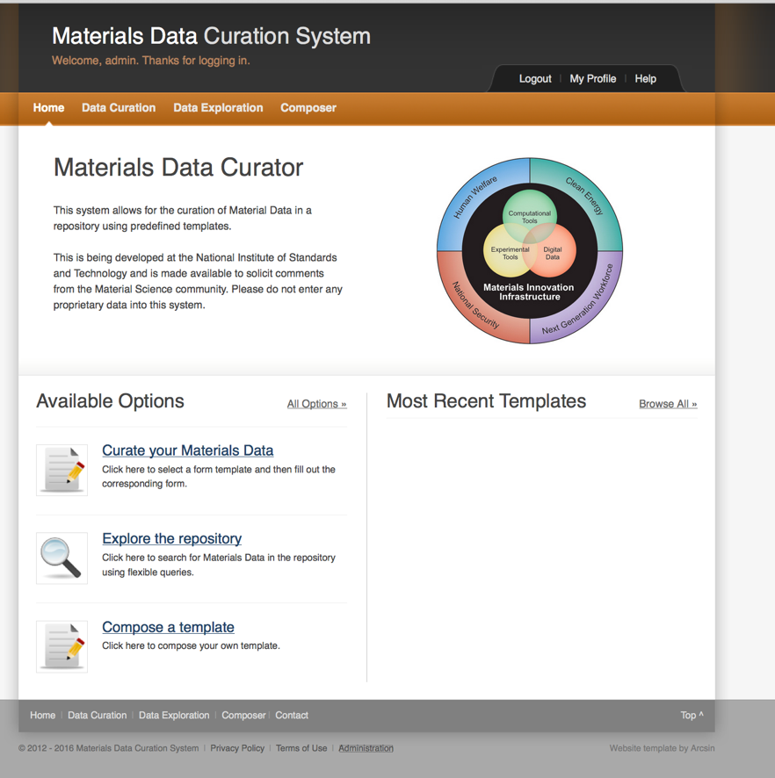

1. Under the “Template & Types” window, select upload template.

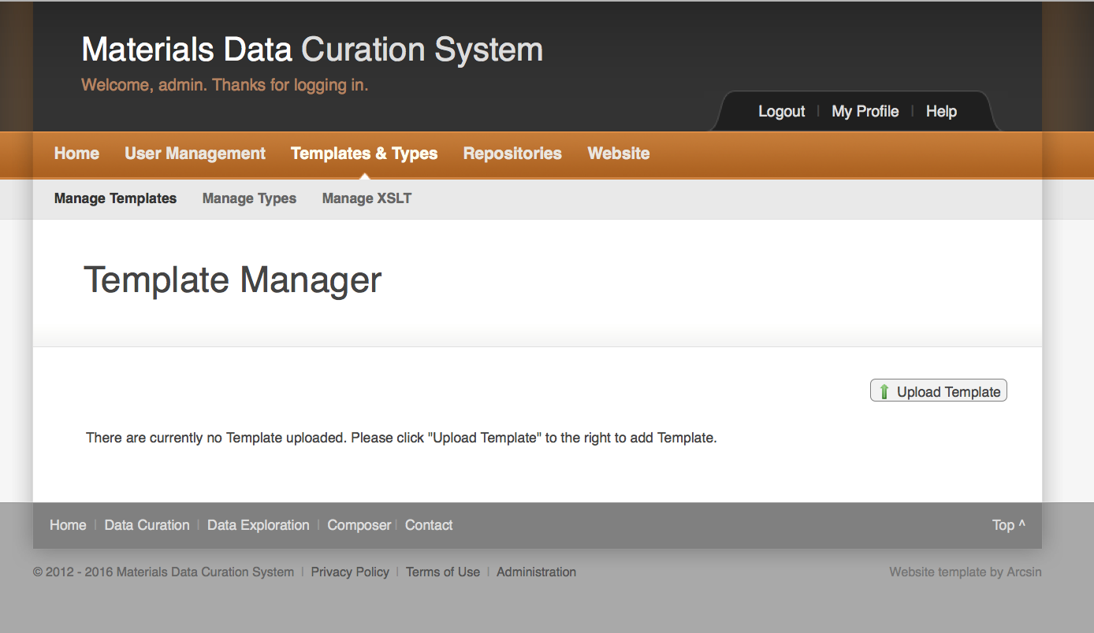

1. Upload the “mod.demo.diffusion.xsd” template and label it “DiffusionDemo”

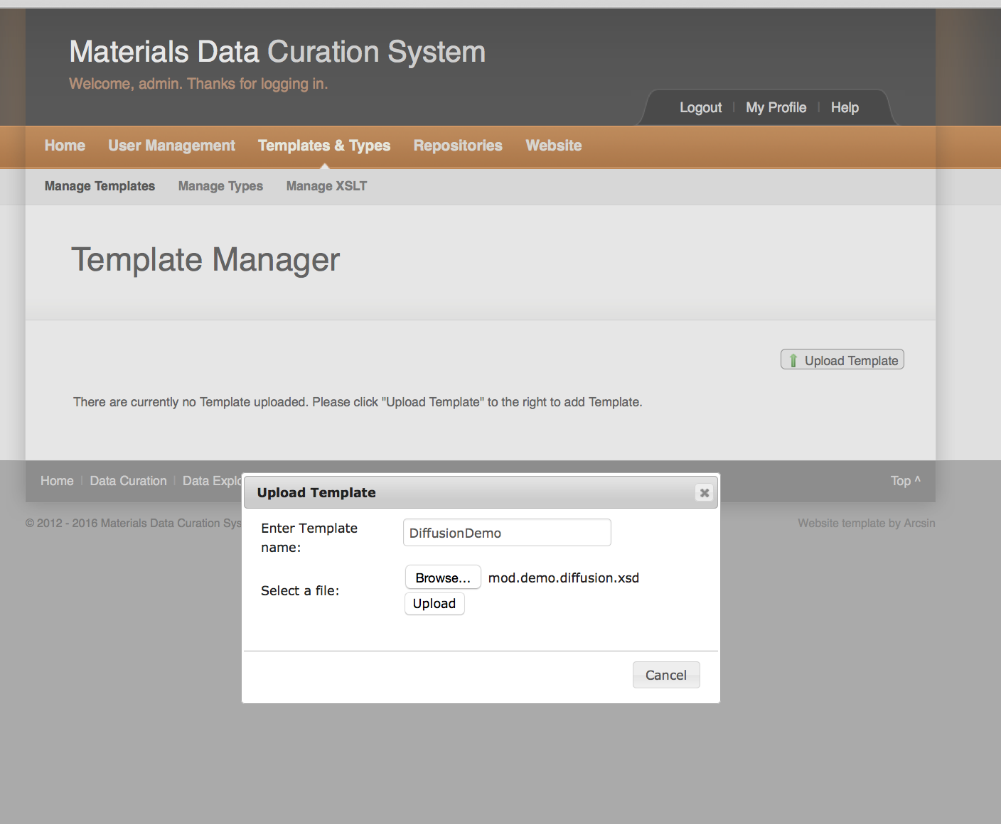

When you have located the file and named the template, click upload. If the upload is successful, you will get a message telling you that you can save the template to the MDCS.

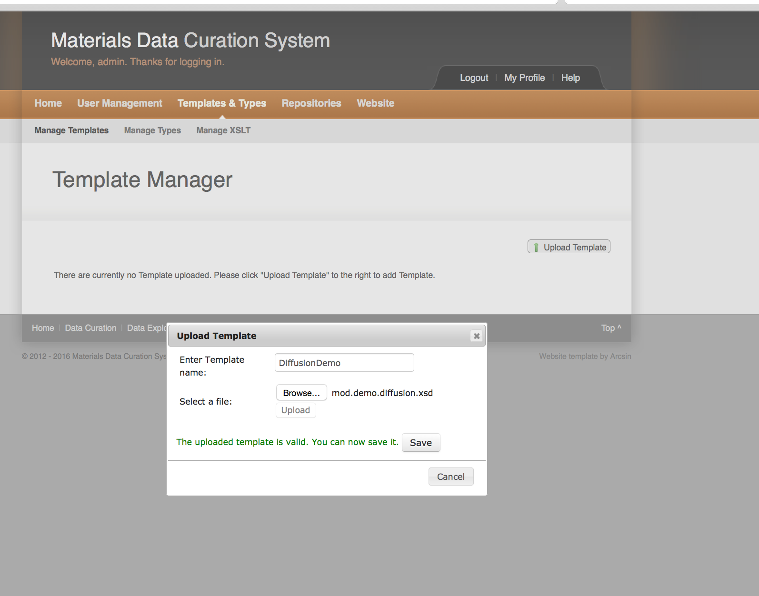

DemoDiffusion

The saved template will then appear in the “Template Manager”

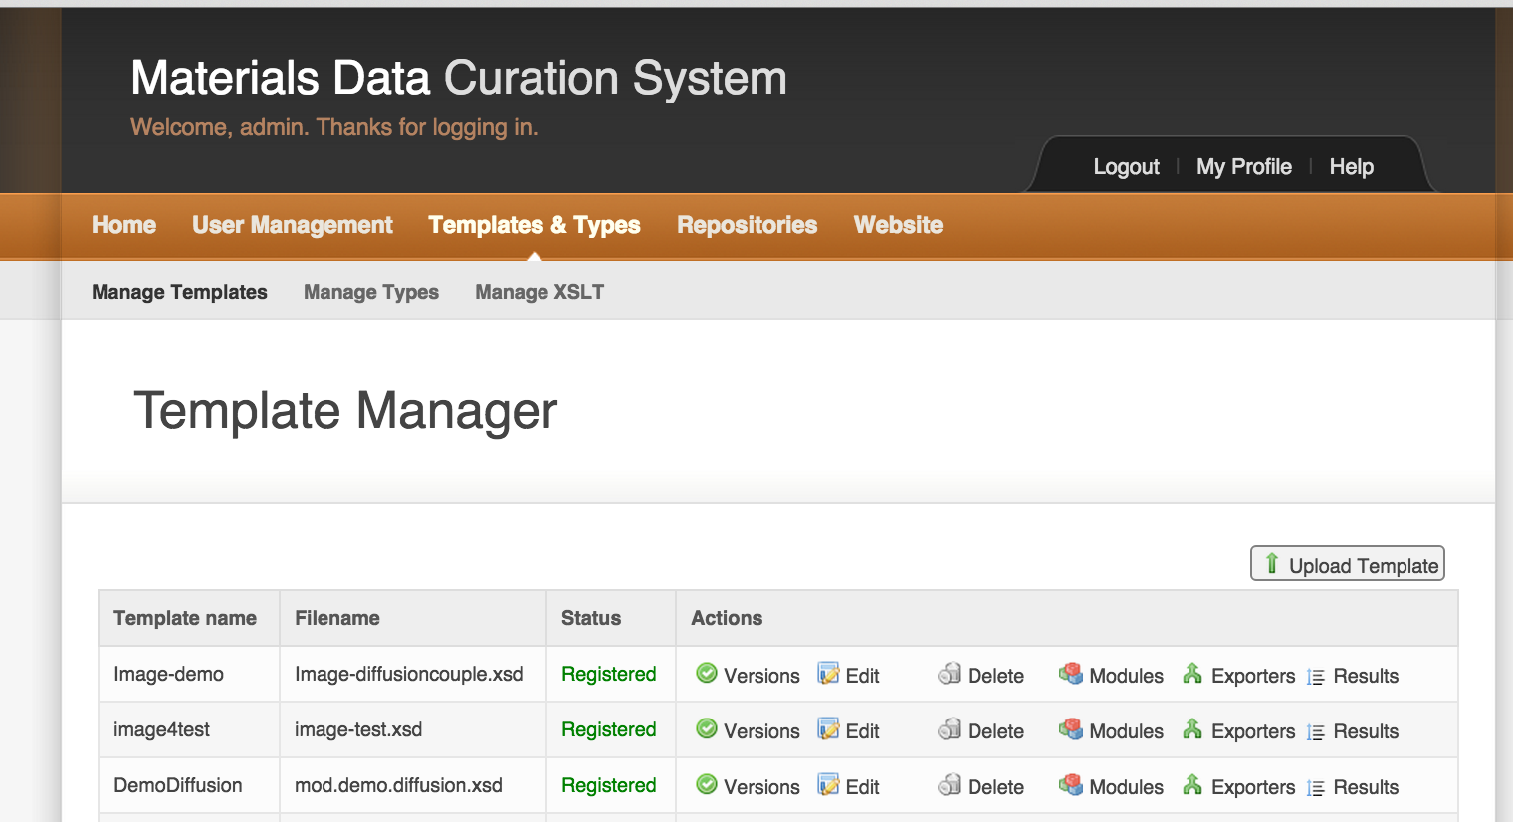

Now that the template has been loaded, we check the available “Exporter” options. To do this click on the “Exporters” in the “DemoDiffusion” row.



Next a menu with a choice of available options will appear

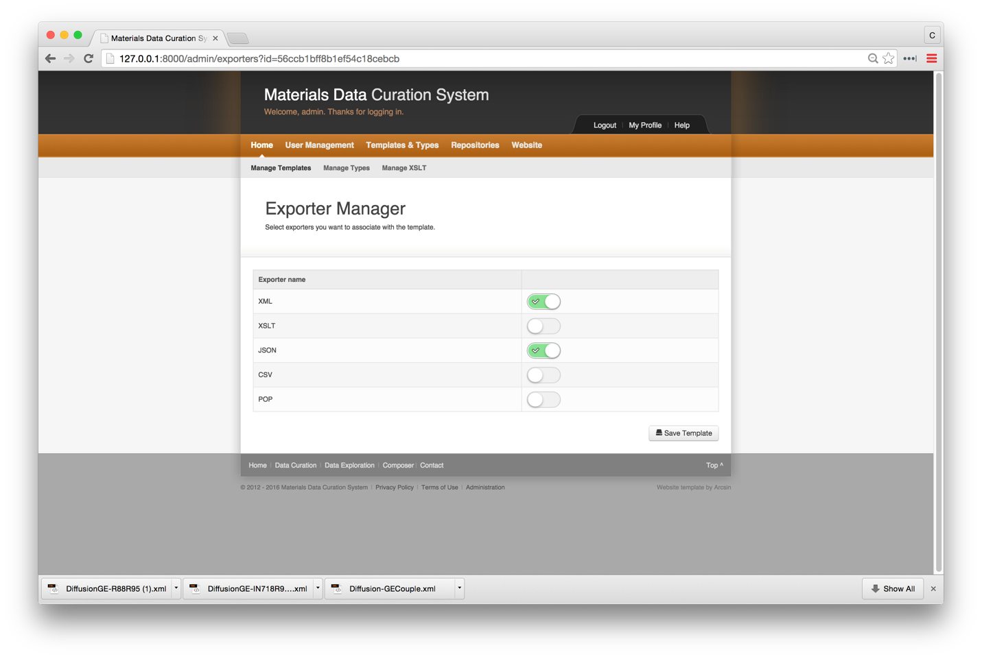

Chose to toggle on the CSV exporter.

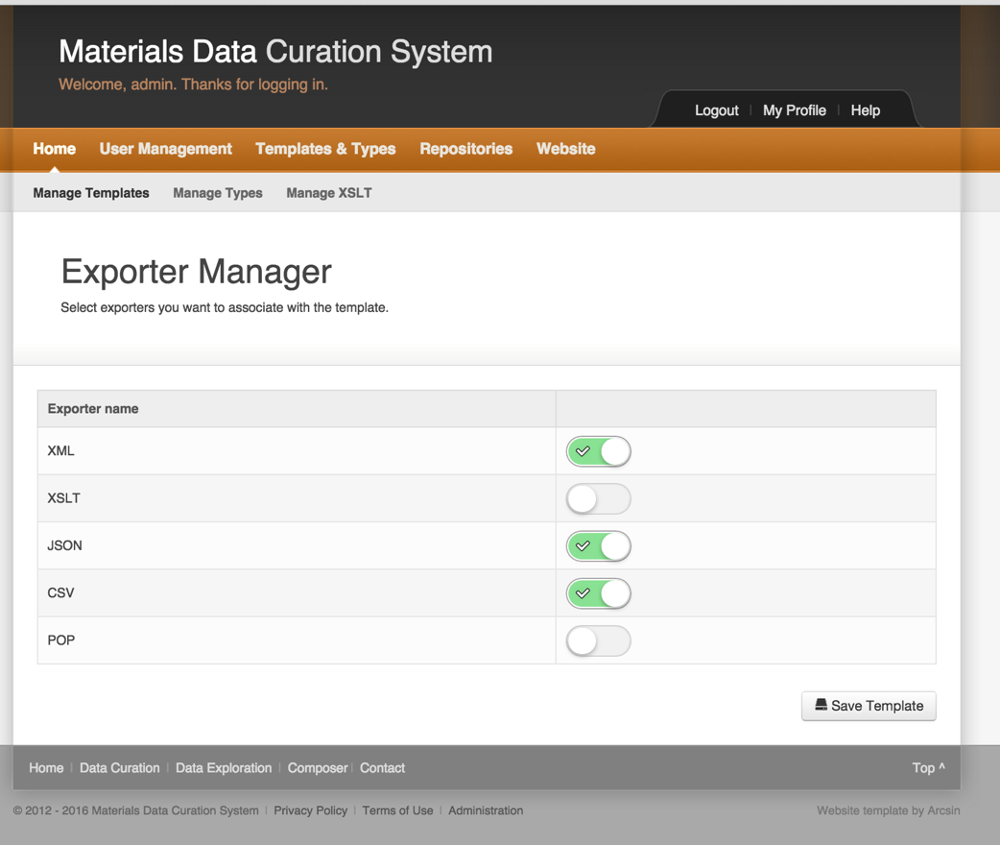

You will then be asked to save the template.

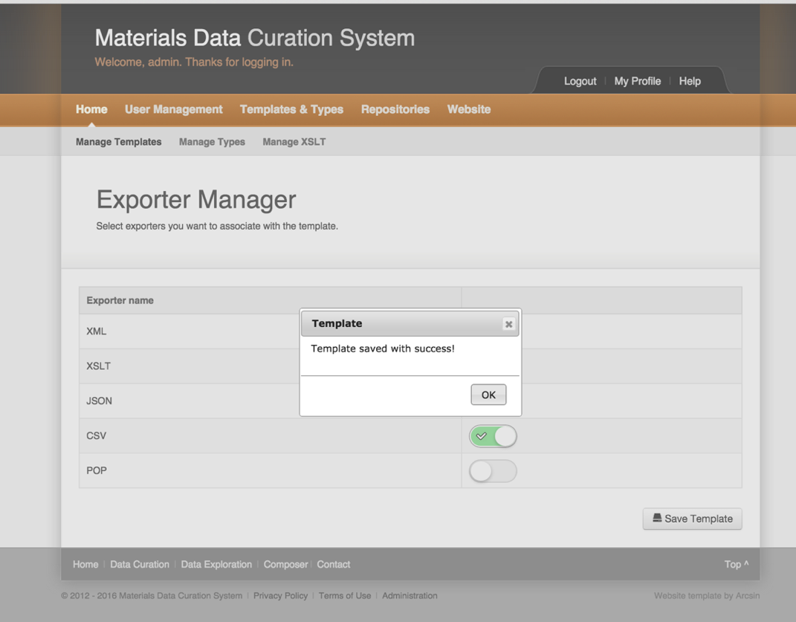

After adding the “Exporters,” return the Template Manager



So return to “Home” screen.

From the “Home” screen, select “Data Curation” on the navigation ribbon or from the “Available Options”



Select “DemoDiffusion” template in the Data Curation Menu

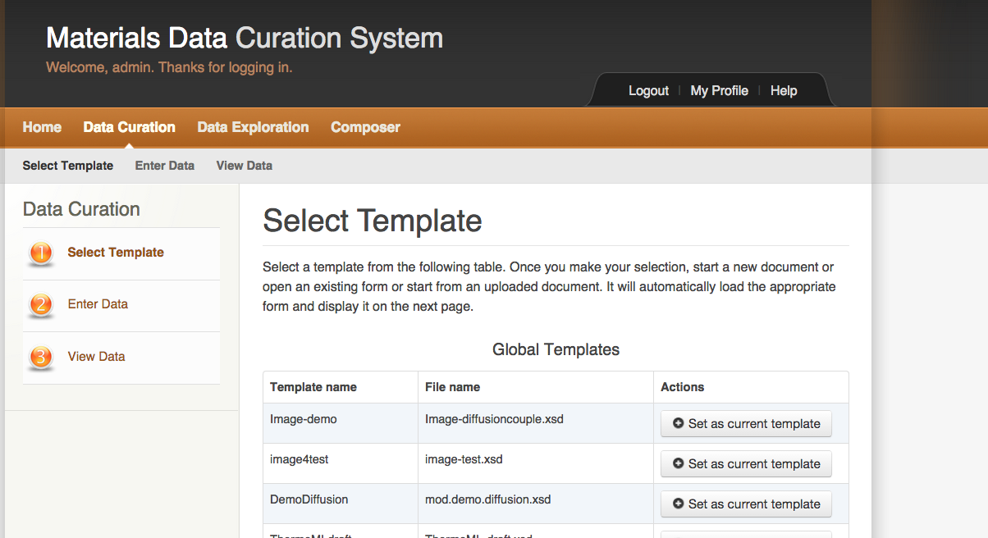

1. Create a new document “new”

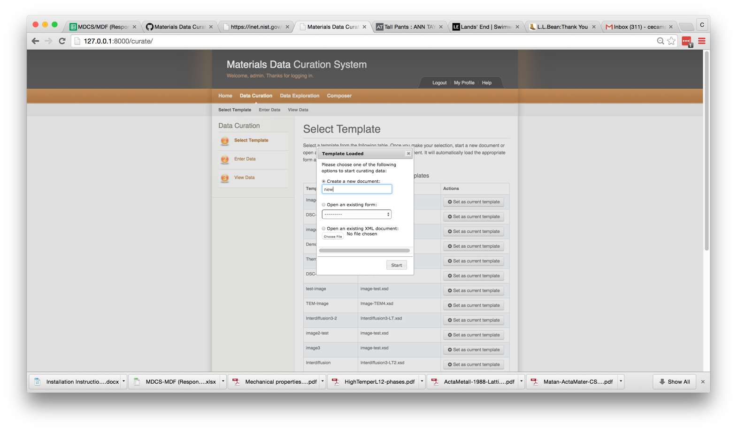

1. The next step is to select the type of diffusion experiment. In this case it is “chemical diffusivity”

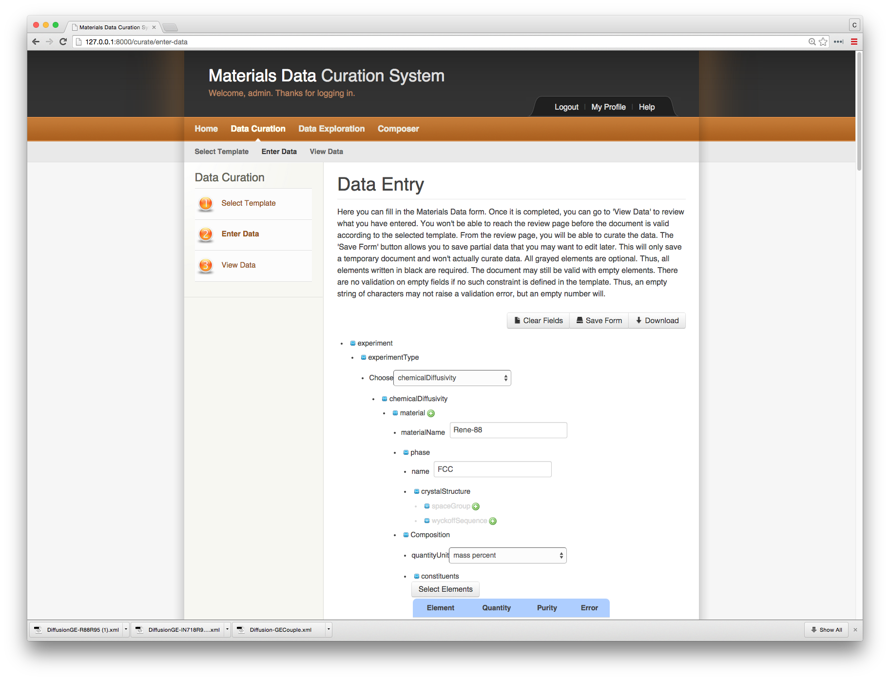

1. Review of schema information (enter material, sample preparation, measurement conditions, composition profile, micrograph)
2. Now return “Select Template” menu and select “DemoDiffusion” template and this time we will upload a partially completed entry

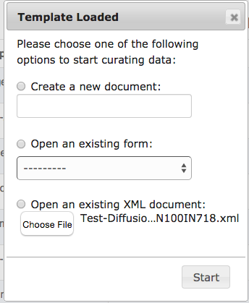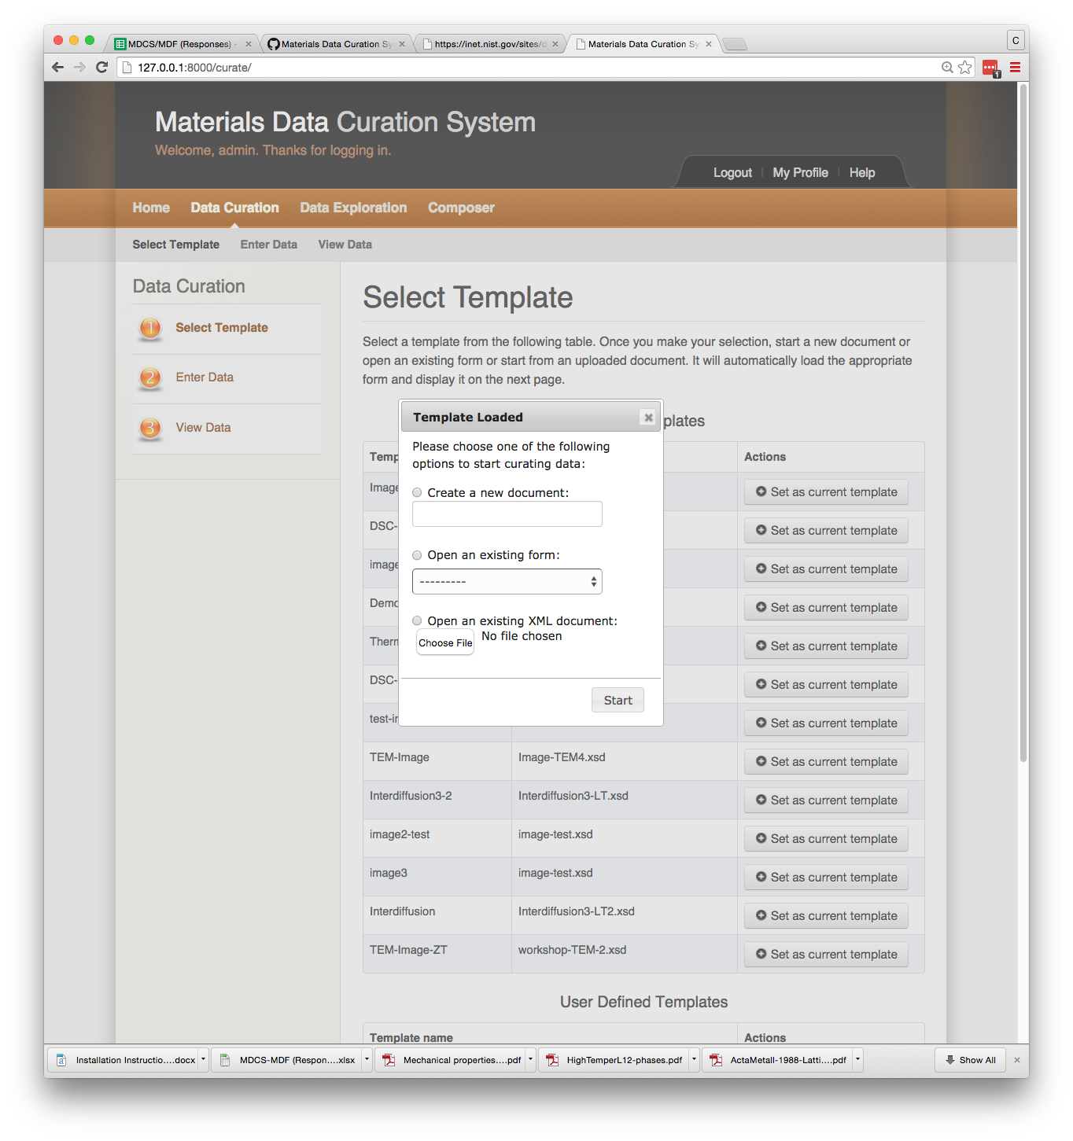

Open the file Test-DiffusionCouple-IN100IN718.xml

Upon opening the “Test-DiffusionCouple IN100IN17.xml” file, you will see that much of the information has been already entered. We enter the composition of IN100, the excel file containing the measured composition profiles, and the micrograph of the diffusion couple.

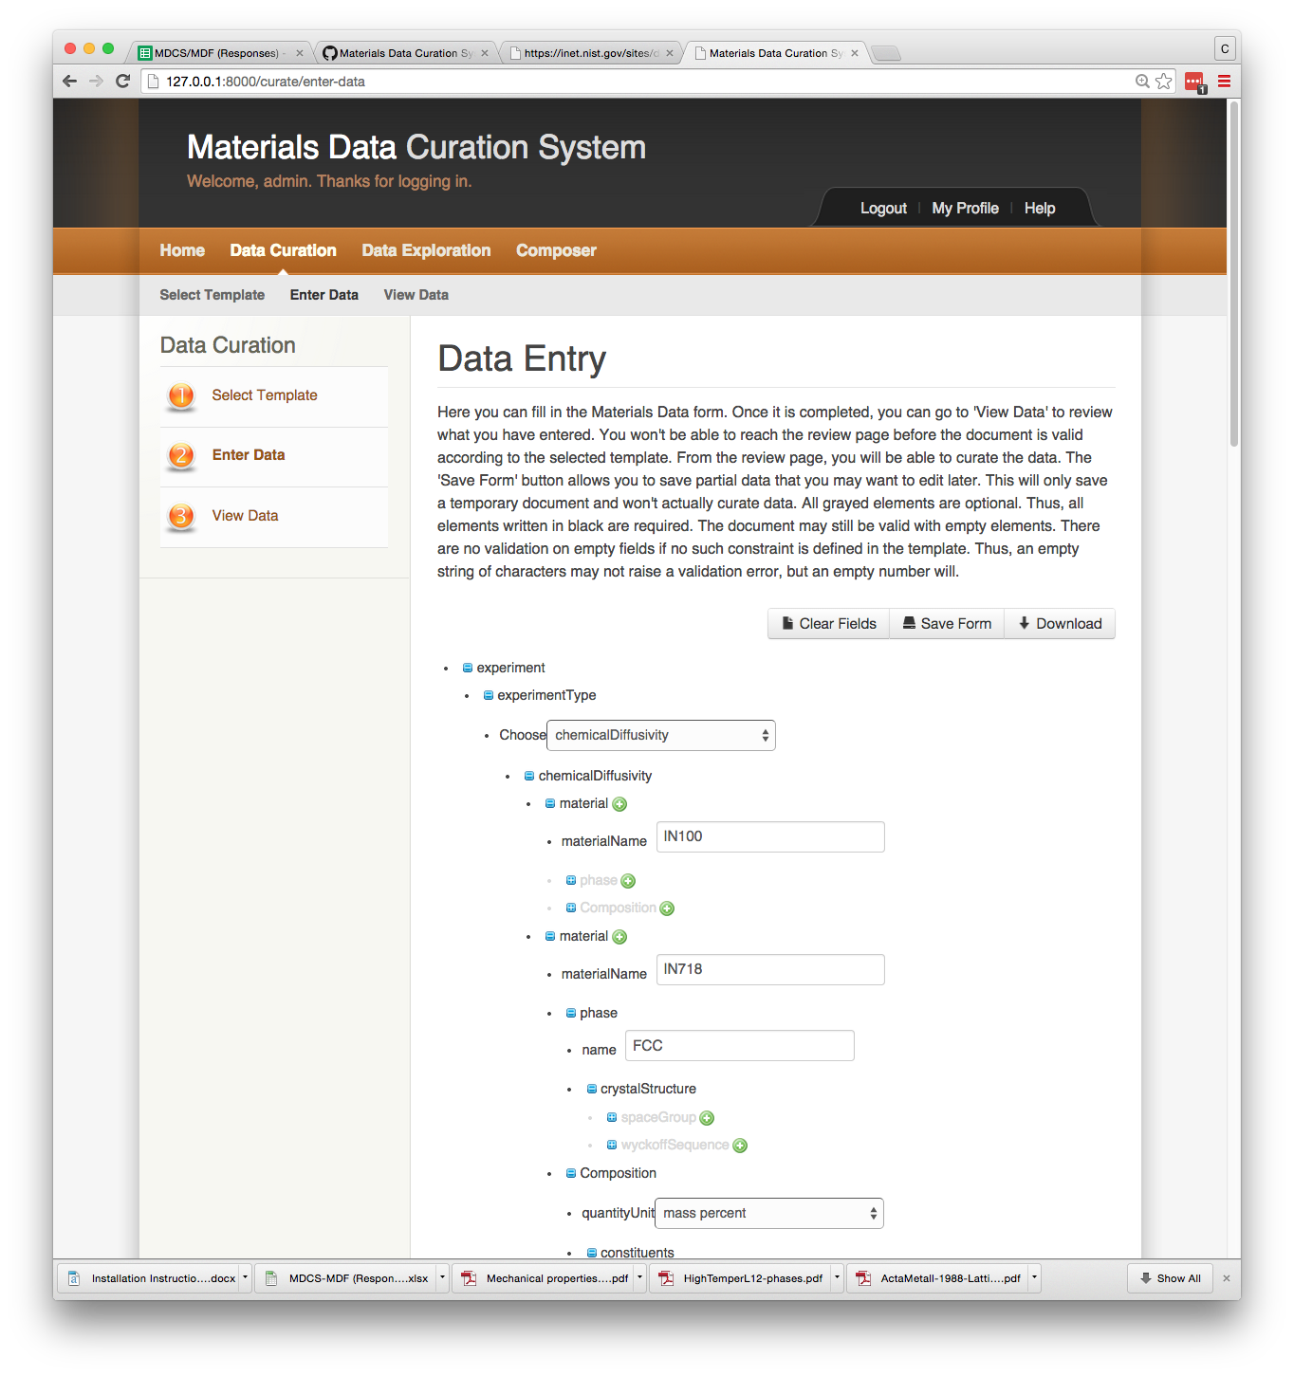

*Need enter phase and composition inn*

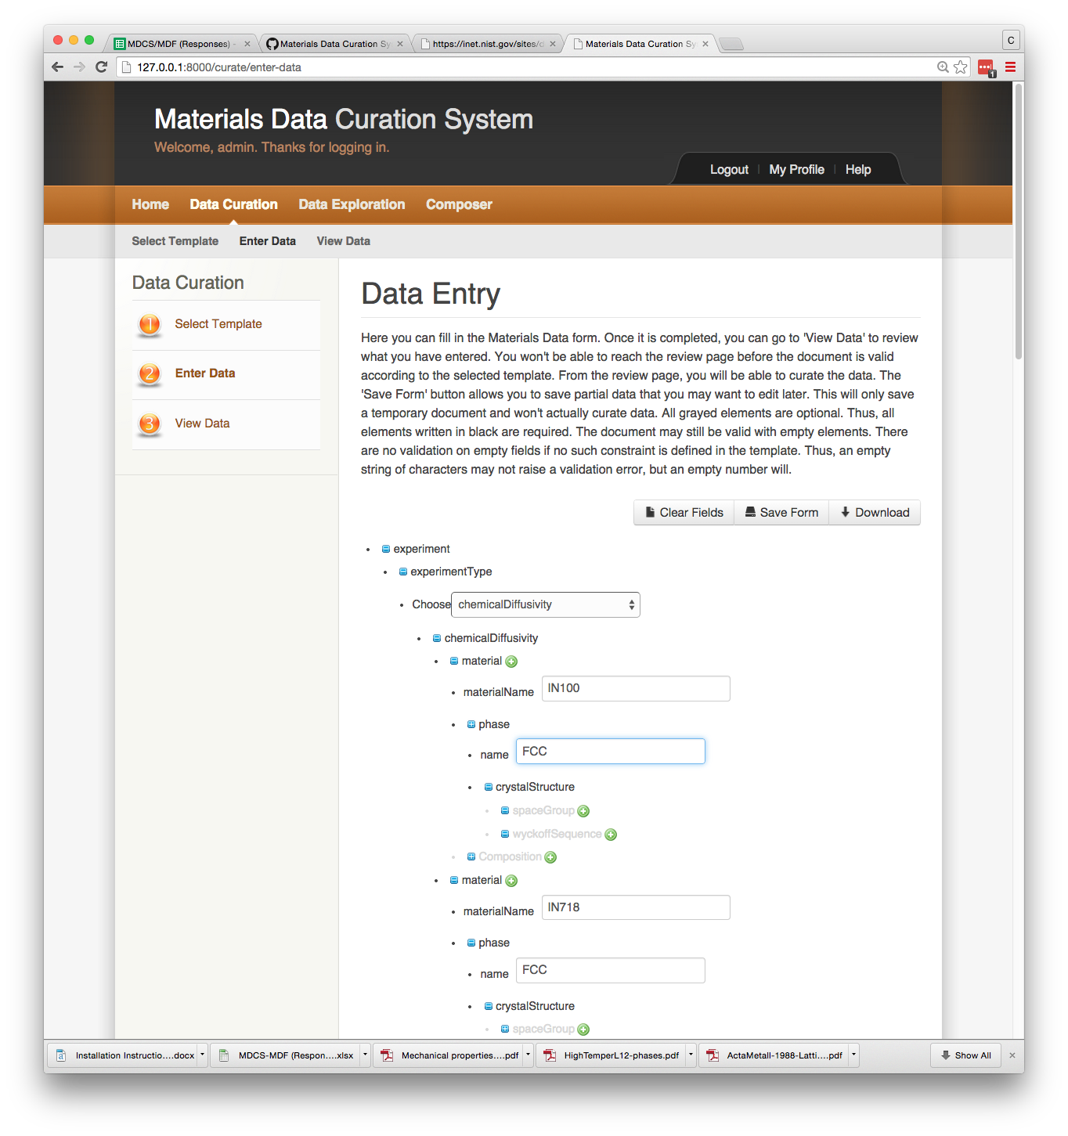

Now enter the composition of IN100: Ni-15Co-10Cr-5.5Al-3Mo-4.7Ti (wt.%) . Select the “quantity Unit” as “mass percent.” Click on “Select Elements” to enter the composition.

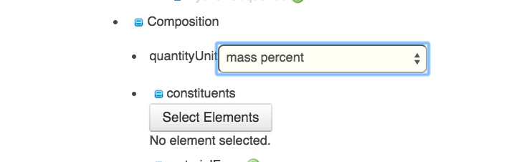

After selecting “Select Element” a periodic table will appear.

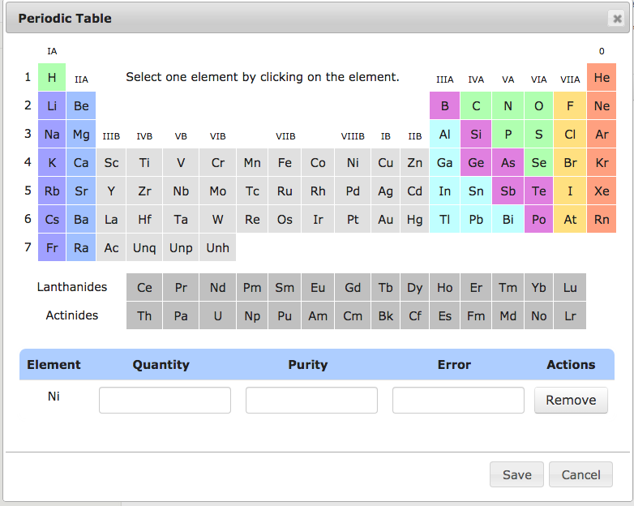

Enter the composition and purity for each element. (Entries for purity and error are required)

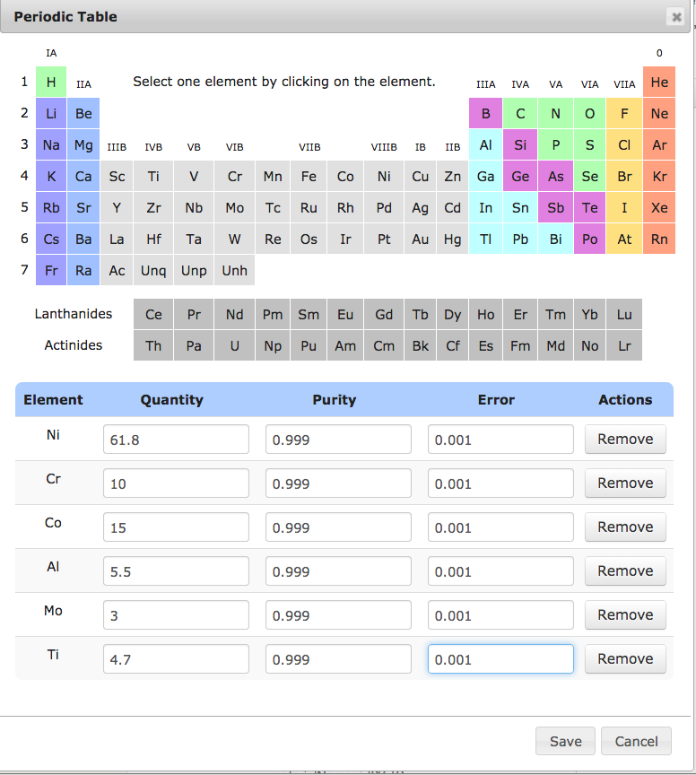

After entering the composition, click on “Save” and the composition table will now appear 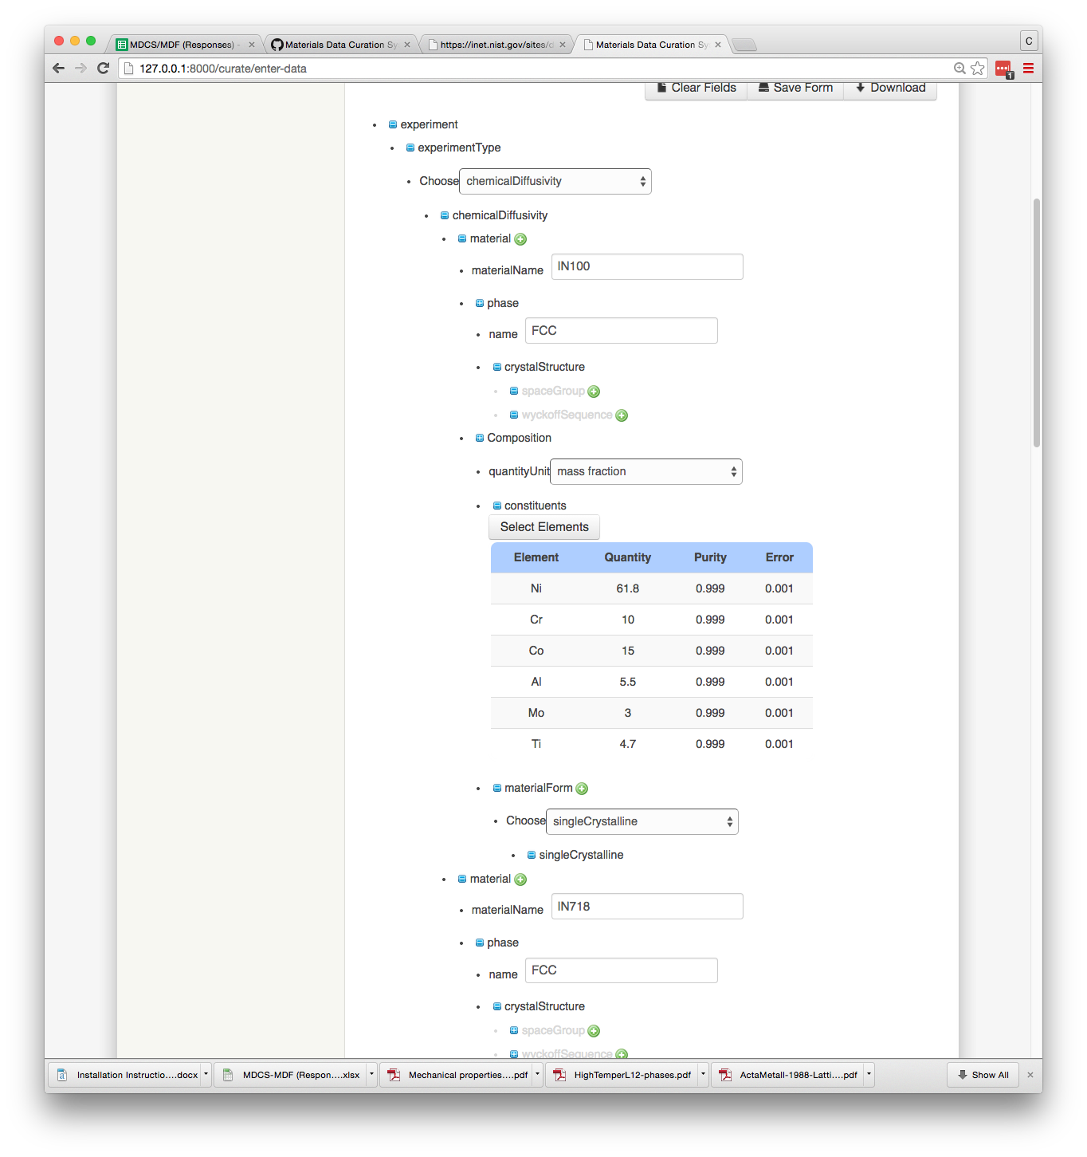

Now enter information on the “materialForm.” In this case the materials is polycrystalline with an average size of 100 m.

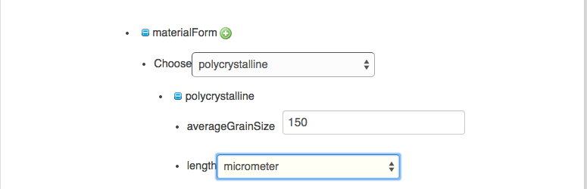

Now scroll down to “Measured Values” and enter the “measuredValues” as “Composition Profiles,” enter “Profile” as the value type, and “click” on “Upload Load Excel”

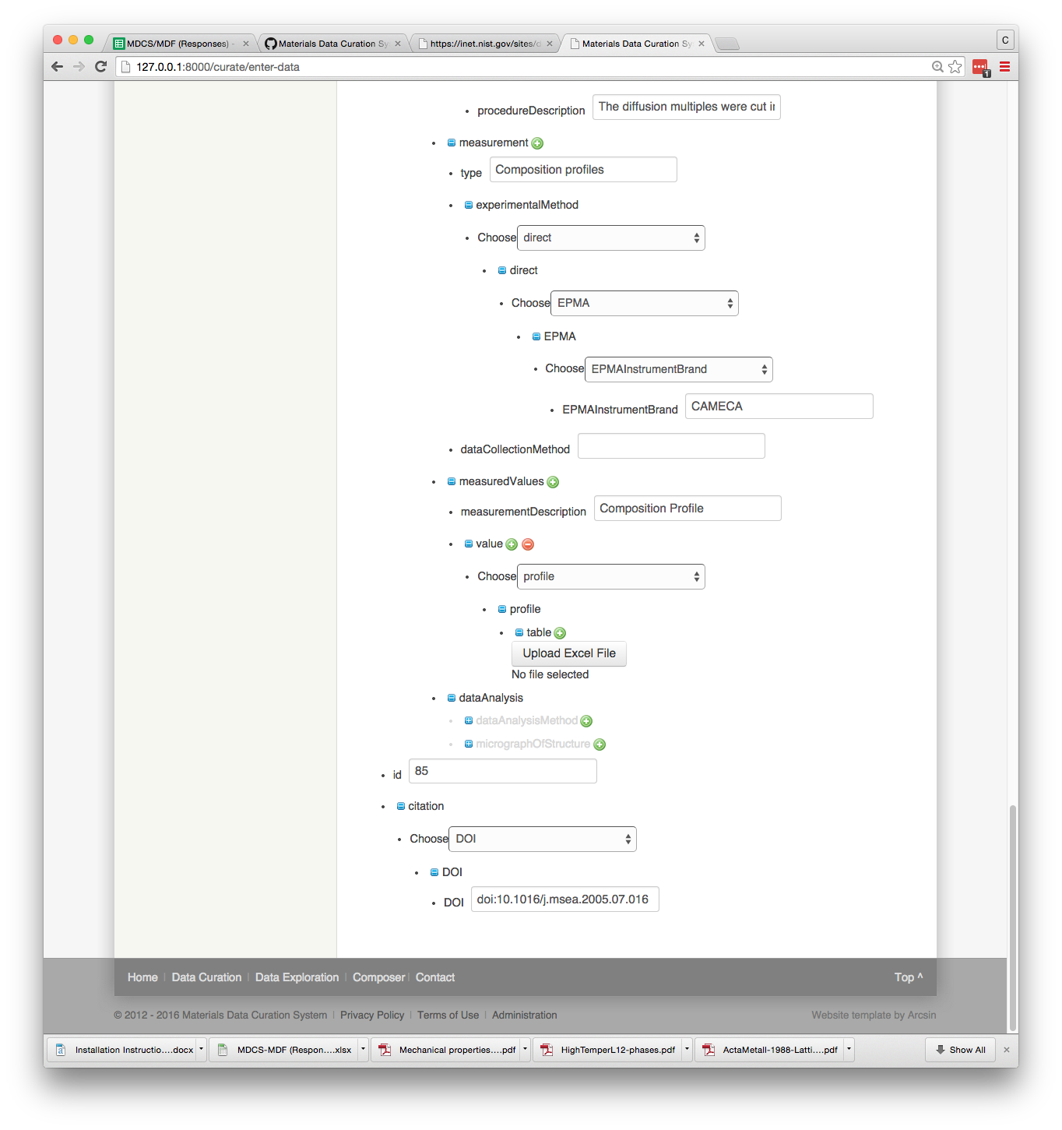

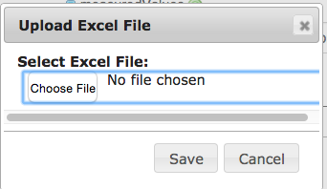

In the pop-up window, choose IN100-IN718 GE-1150C-1000h.xlsx file and “Save”

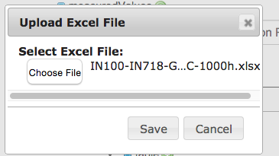

After uploading the Excel file, the table will appear in the form.

Now add the micrograph to the data record.

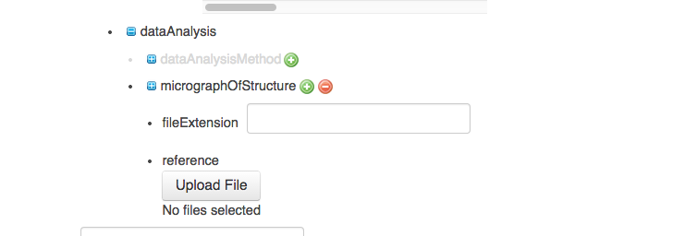

Enter the file type and upload the micrograph (IN100-IN718-crop.TIFF)

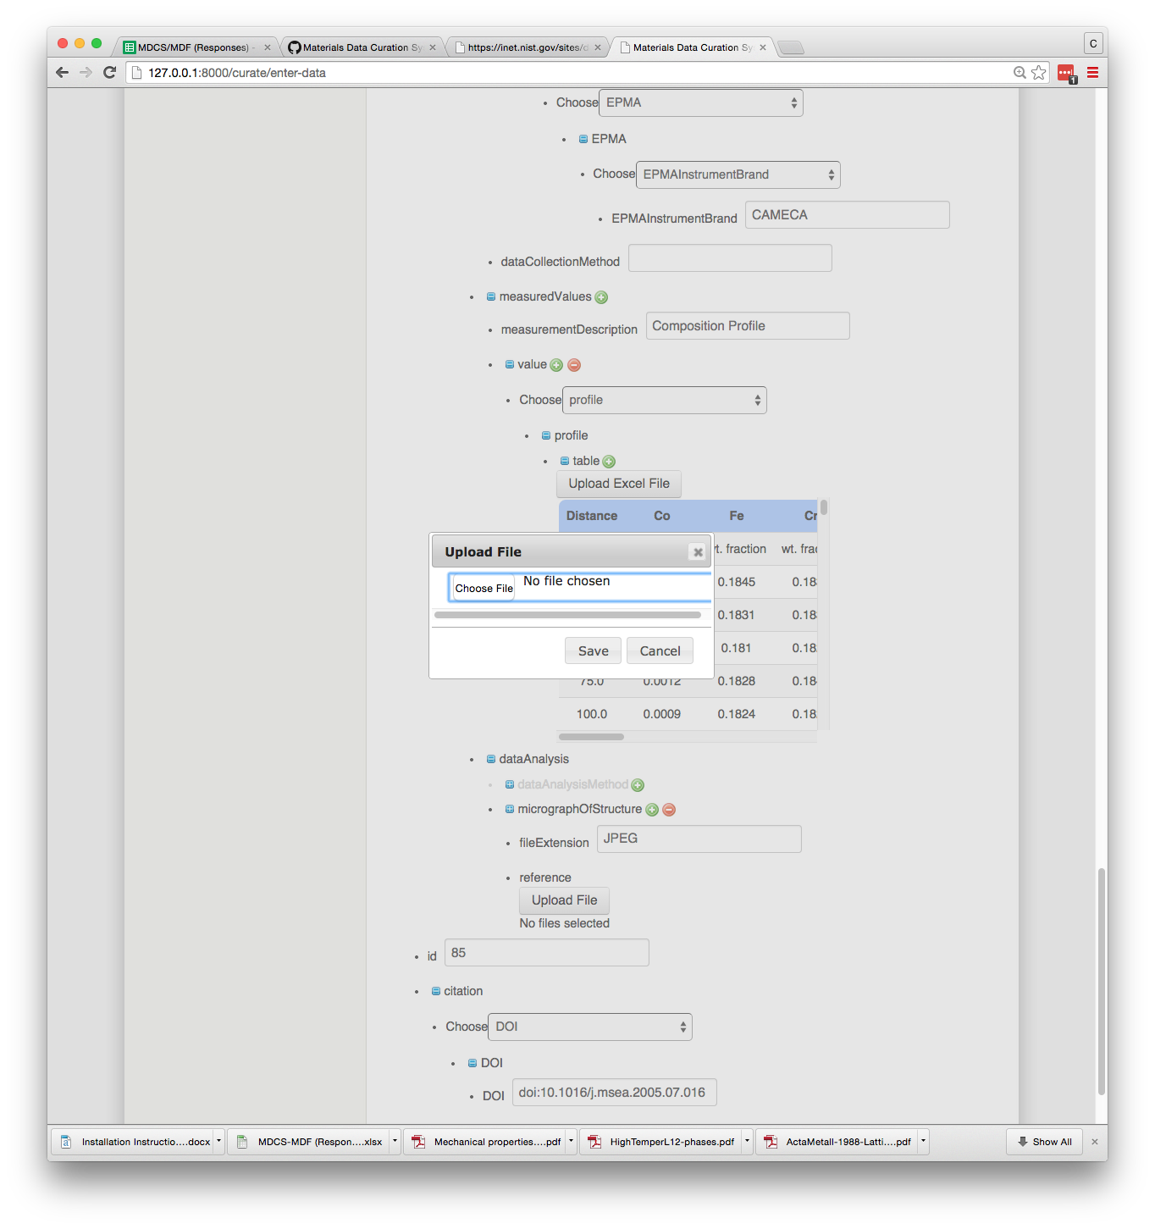

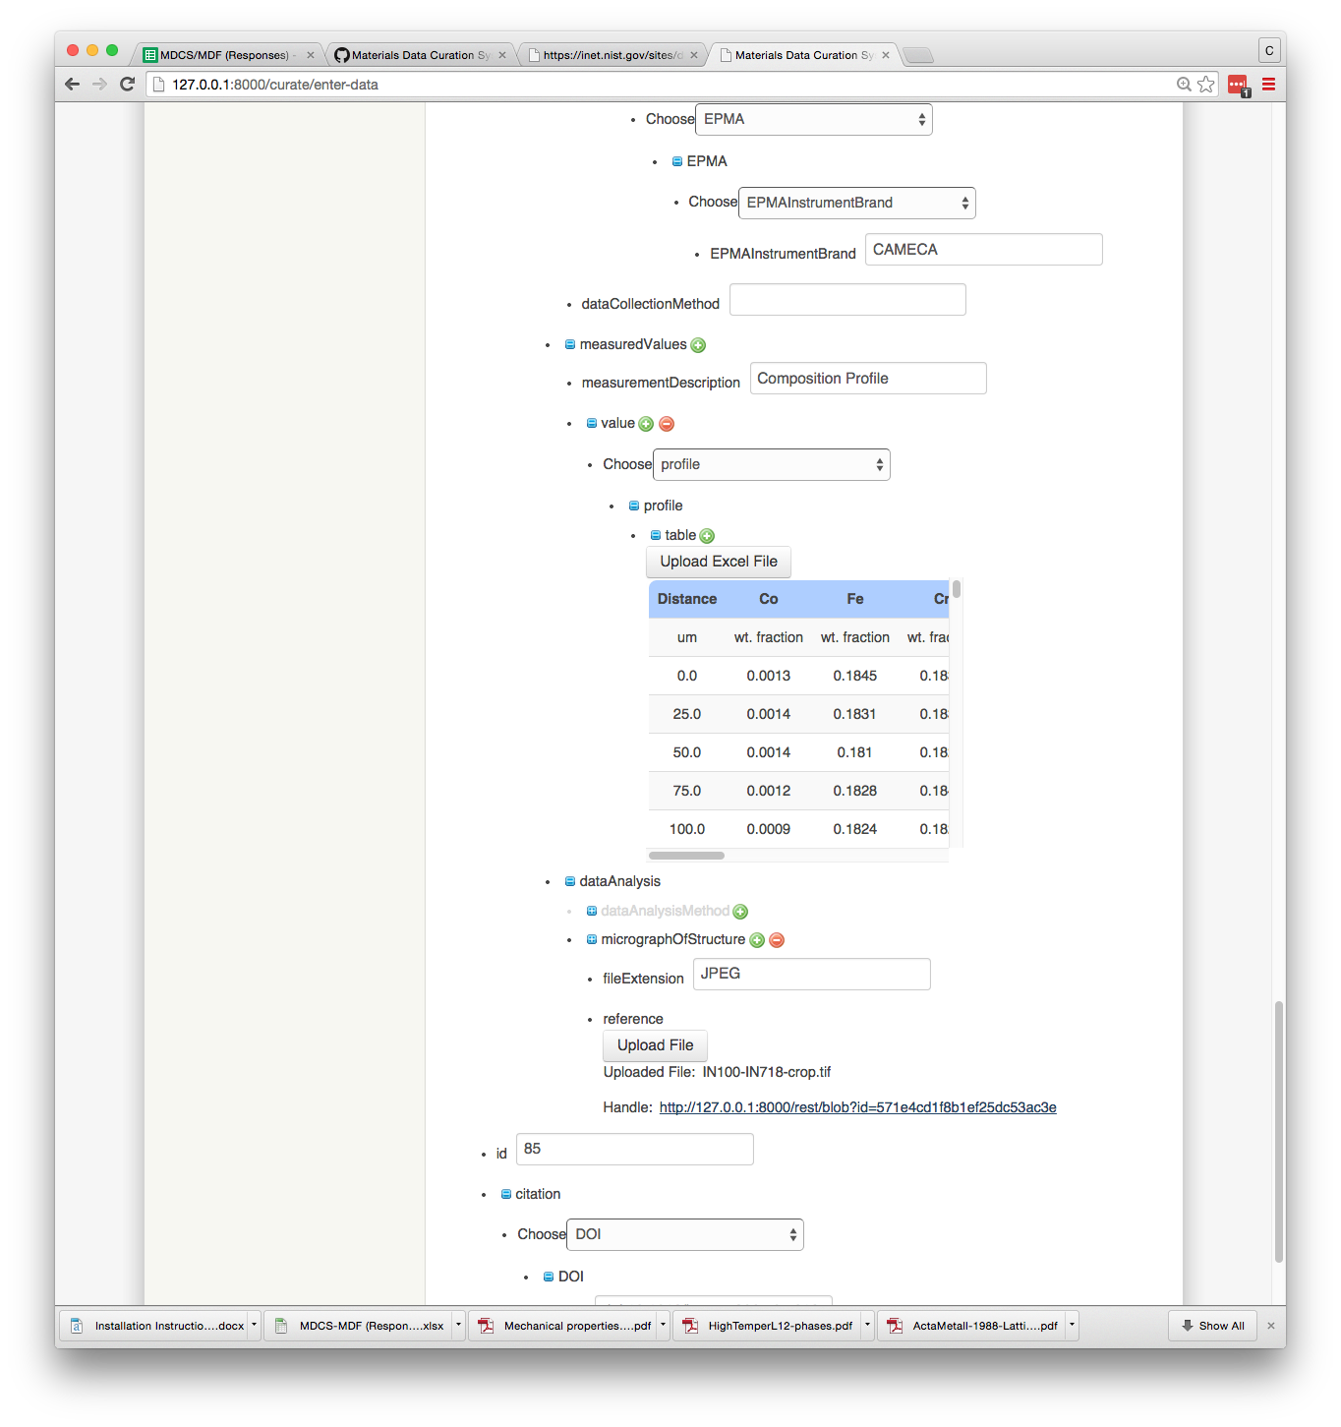

TIFF

You can now view the entered data in the XML format and save the data to the repository.

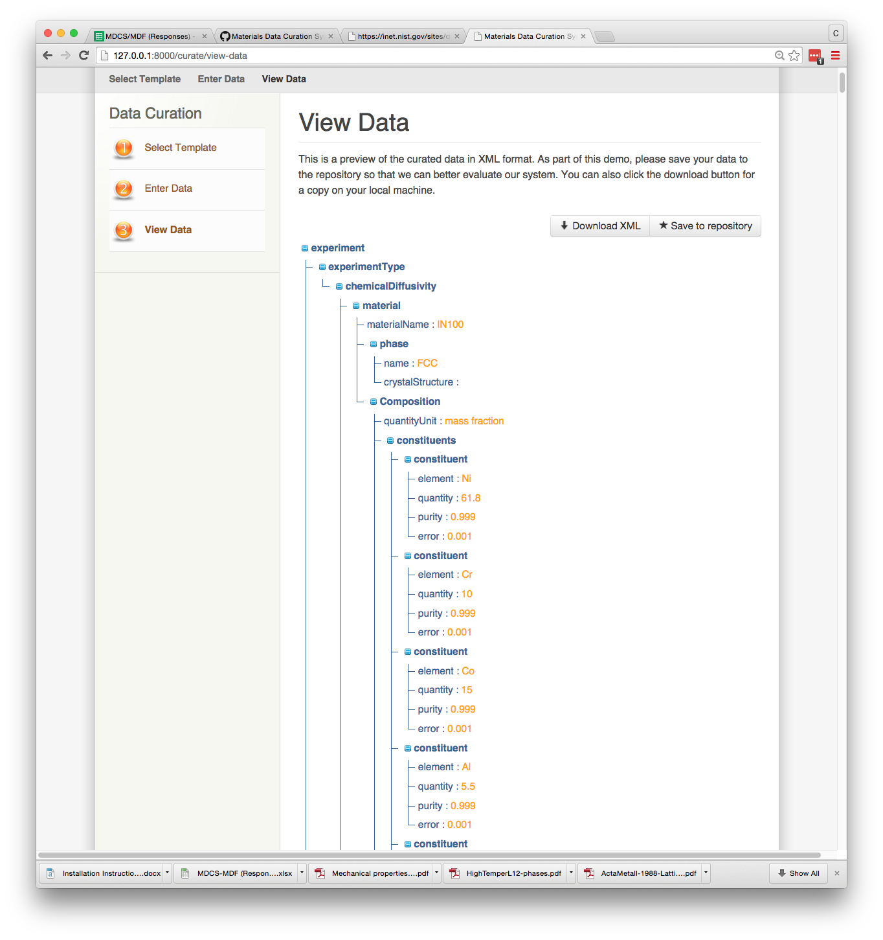

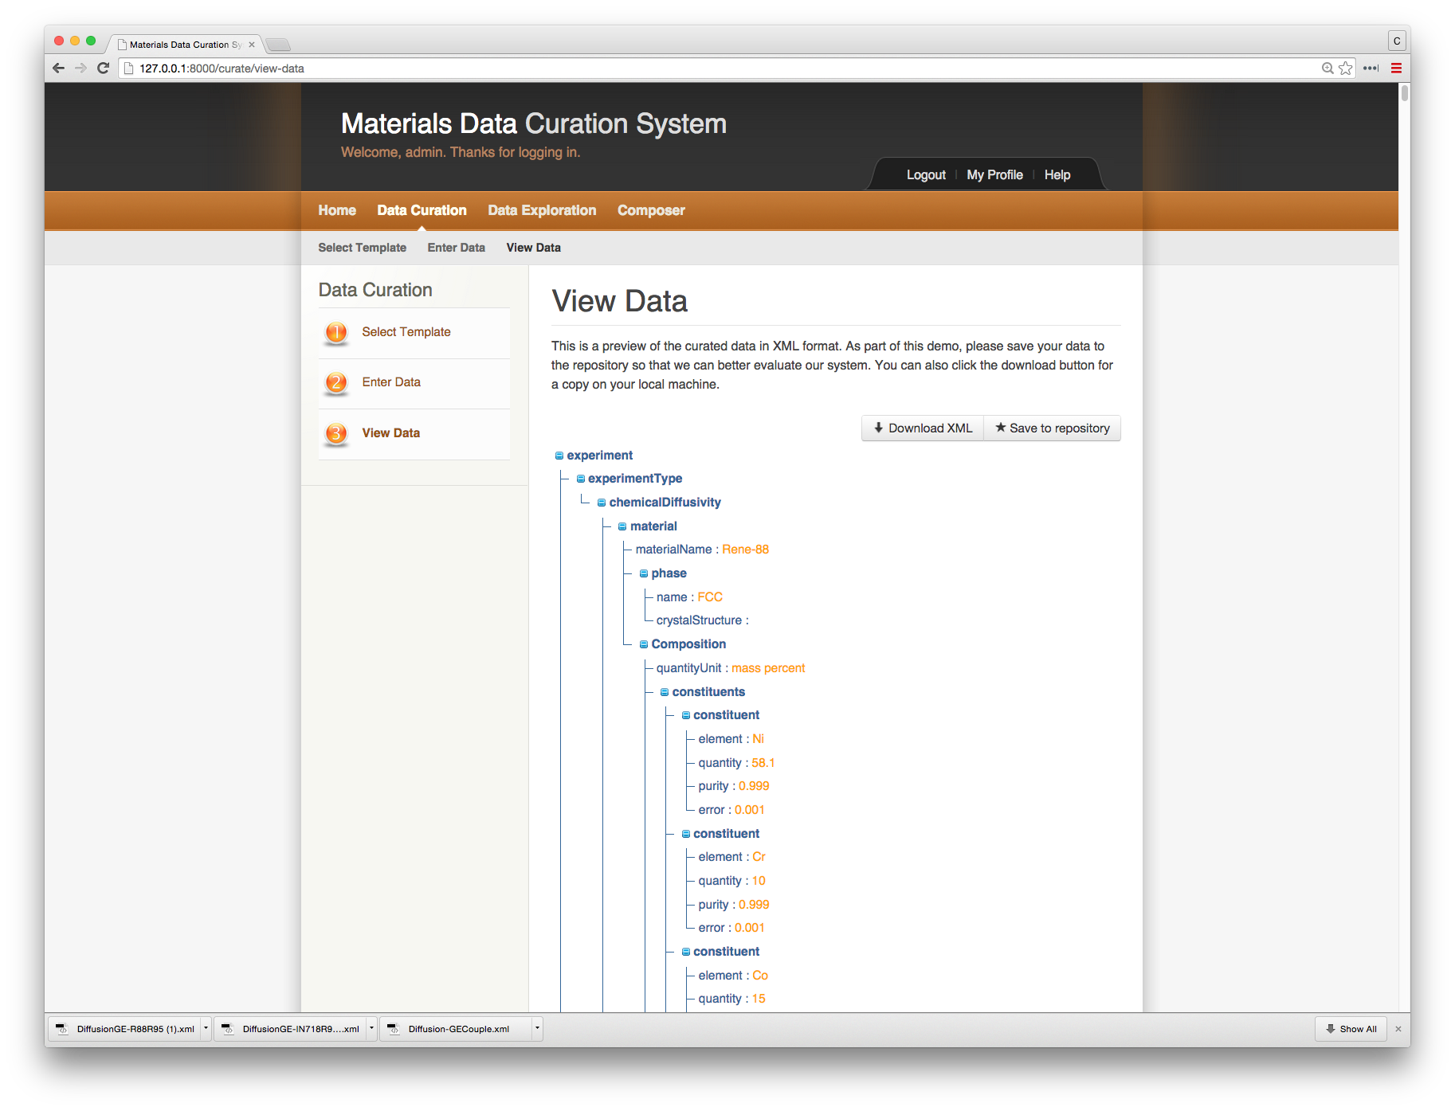

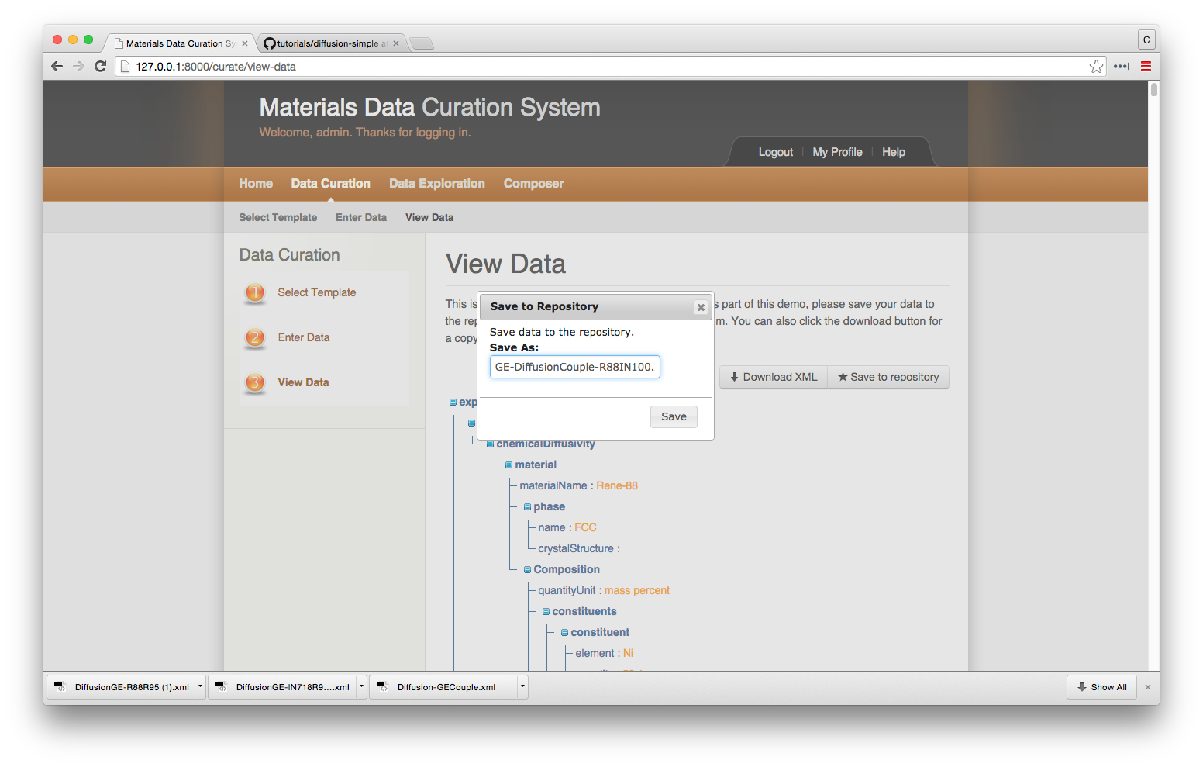

You can also download a copy of the XML entry.



In the “Data Exploration” tutorial we will then view this data and export the spreadsheet.